

**FORGIVENESS**

**Worship 2 go**

**Bringing home and school together**

Bible verse: *“Their sins and lawless acts I will remember no more. (Hebrews 10:17)*

God forgets. He doesn’t forget us or forget what he has to do every day. But he forgets our sins. Our mistakes. Our bad choices. The minute we come to him and ask for forgiveness, he wipes the slate clean, he forgets.

That’s fantastic! And hard to imagine.

When our friends do something to hurt us, we remember. We remember when a teammate makes a bad play. We also remember our own stuff, like when we lied or cheated or got in trouble with our parents.

Its harder for us to forget what we’ve done or what others have done to us.

God knows that we won’t forget, but he doesn’t want us to hold onto bad feelings, hate or resentment. If someone asks for our forgiveness, we need to offer forgiveness and be done with it, even if we need to ask God to help us with that choice every day. God doesn’t hold onto bad stuff we do, and he doesn’t want us to hold onto it either.

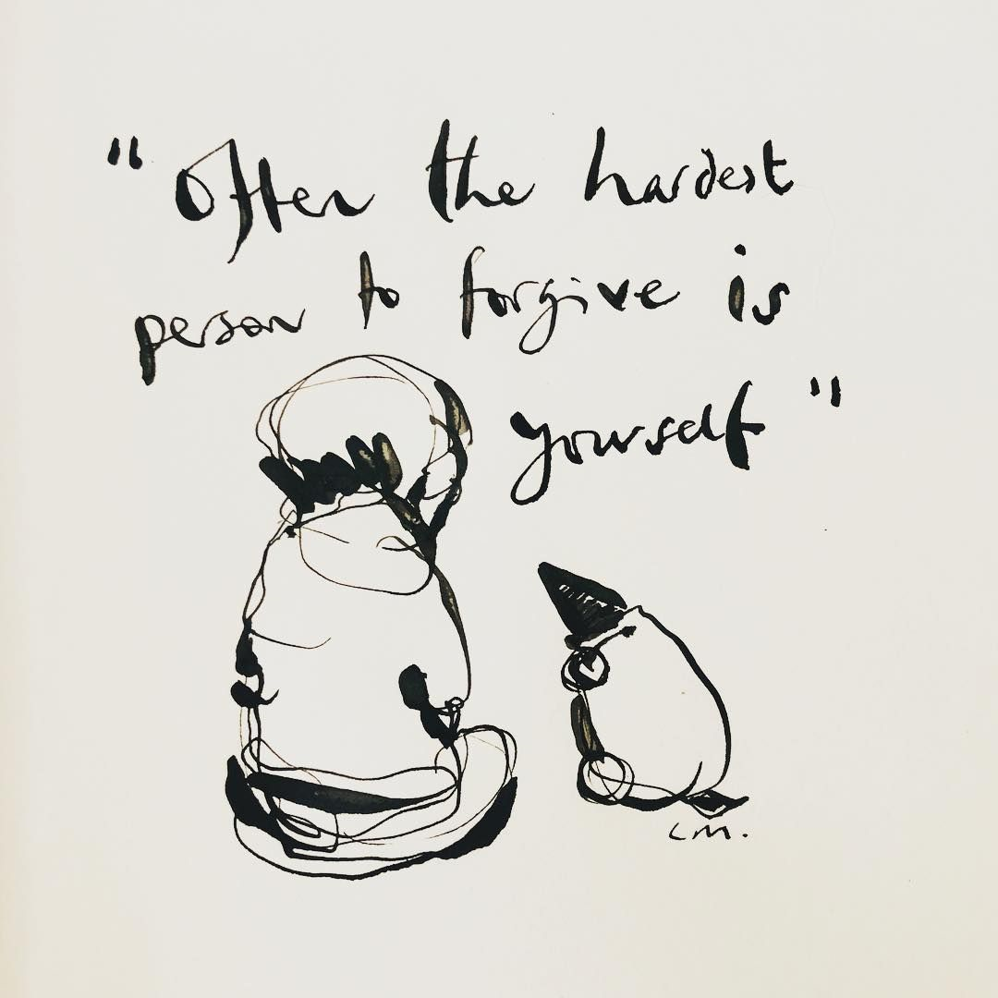[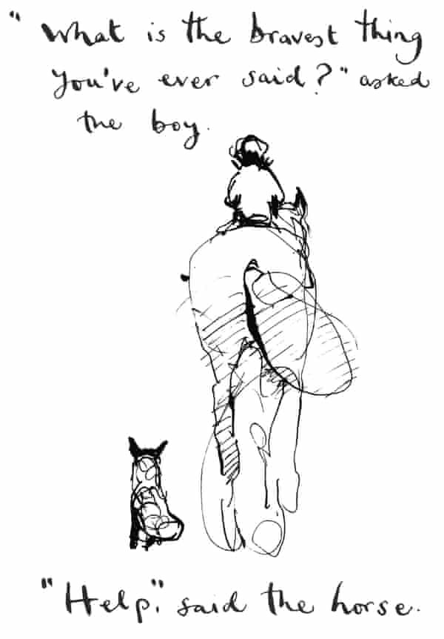](https://www.google.com/url?sa=i&url=https%3A%2F%2Fwww.theguardian.com%2Fbooks%2F2019%2Fnov%2F09%2Fboy-mole-fox-horse-christmas-bestseller-charlie-mackesy&psig=AOvVaw3xPV3dA0WwRZfmnAbdT86e&ust=1589884440145000&source=images&cd=vfe&ved=0CAIQjRxqFwoTCPCA3JybvekCFQAAAAAdAAAAABAE)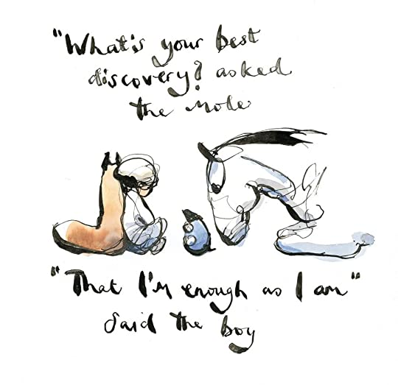

Daily prayer

Lord, help me not to hold onto bad choices I’ve made or the hurt from others. I want to forget the things that you forget.