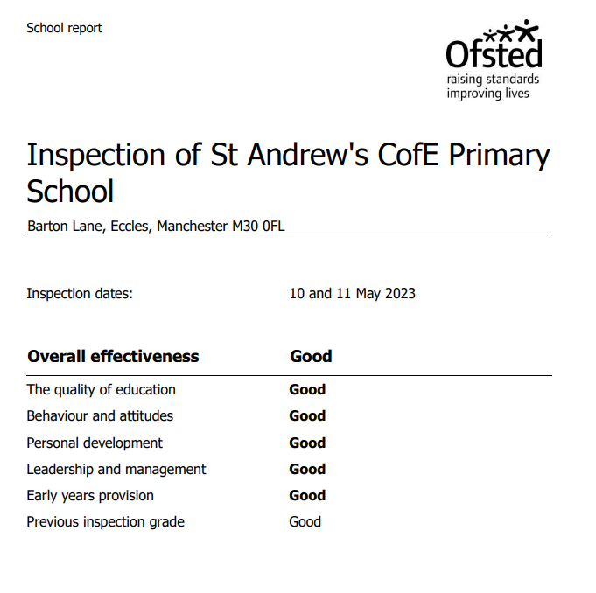
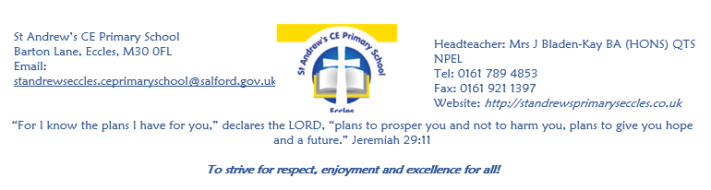

Pupil premium strategy statement

Before completing this template, you should read the using pupil premium guide and the appropriate example statement available on the pupil premium page.

Before publishing your completed statement, you should delete the instructions (text in italics) in this template, including this text box.

This statement details our school’s use of pupil premium (and recovery premium for the 2022 to 2023 academic year) funding to help improve the attainment of our disadvantaged pupils.

It outlines our pupil premium strategy, how we intend to spend the funding in this academic year and the effect that last year’s spending of pupil premium had within our school.

School overview
Detail | Data
School name | St Andrews Church of England Primary School, Eccles
Number of pupils in school | 230
Proportion (%) of pupil premium eligible pupils | 43
Academic year/years that our current pupil premium strategy plan covers (3 year plans are recommended) | 2025-2028
Date this statement was published | 05.09.25
Date on which it will be reviewed | 01.07.26
Statement authorised by | Mrs Bladen-Kay
Pupil premium lead | Mrs J Simpson
Governor / Trustee lead
Funding overview
Detail | Amount
Pupil premium funding allocation this academic year | 147, 570
Pupil premium funding carried forward from previous years (enter £0 if not applicable) | 0
Total budget for this academic year  If your school is an academy in a trust that pools this funding, state the amount available to your school this academic year | 147,570

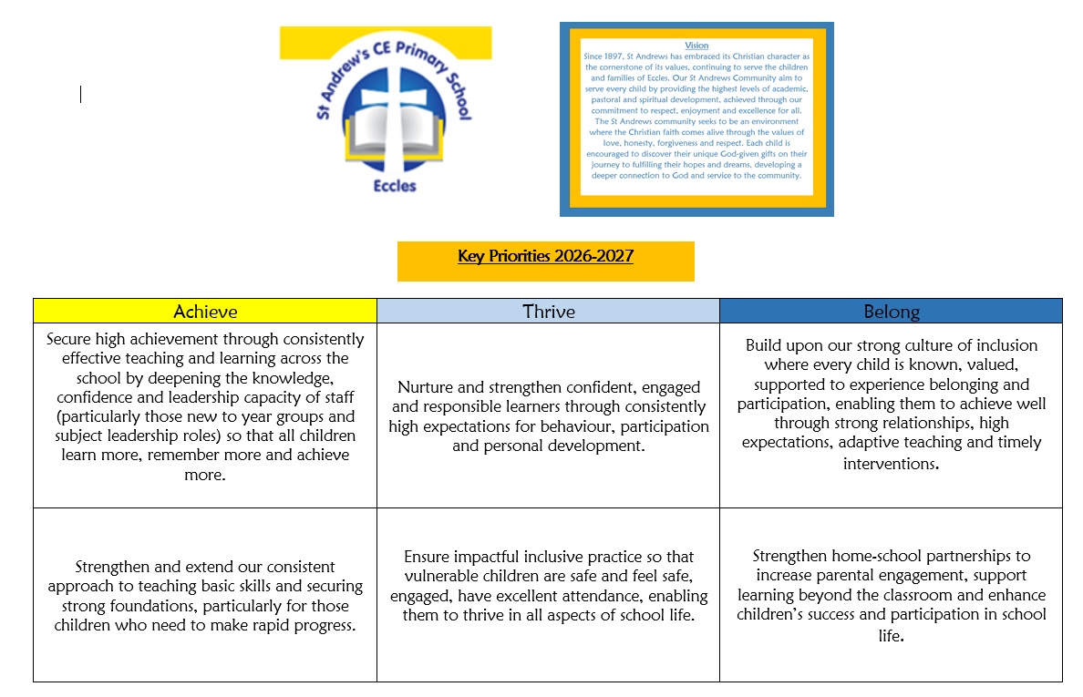
Statement of intent (please see SDP)
Our intention is that all pupils, irrespective of their background or the challenges they face, make good progress and achieve high attainment across all subject areas. The focus of our pupil premium strategy is to support disadvantaged pupils to achieve that goal, including progress for those who are already high attainers.
We will consider the challenges faced by vulnerable pupils, such as those who have a social worker.
High-quality teaching and learning is at the heart of our approach, with a focus on areas in which disadvantaged pupils require the most support. This is proven to have the greatest impact on closing the disadvantage attainment gap and at the same time will benefit the non-disadvantaged pupils in our school. Implicit in the intended outcomes detailed below, is the intention that non-disadvantaged pupils’ attainment will be sustained and improved alongside progress for their disadvantaged peers.
Our approach will be responsive to common challenges and individual needs, rooted in robust diagnostic assessment, not assumptions about the impact of disadvantage. The approaches we have adopted complement each other to help pupils excel. To ensure they are effective we will:
- ensure disadvantaged pupils are challenged in the work that they’re set
- act early to intervene at the point need is identified
- adopt a whole school approach in which all staff take responsibility for disadvantaged pupils’ outcomes and raise expectations of what they can achieve

Key Priorities from the School Development Plan

Challenges

This details the key challenges to achievement that we have identified among our disadvantaged pupils.
Challenge number | Detail of challenge
1 | 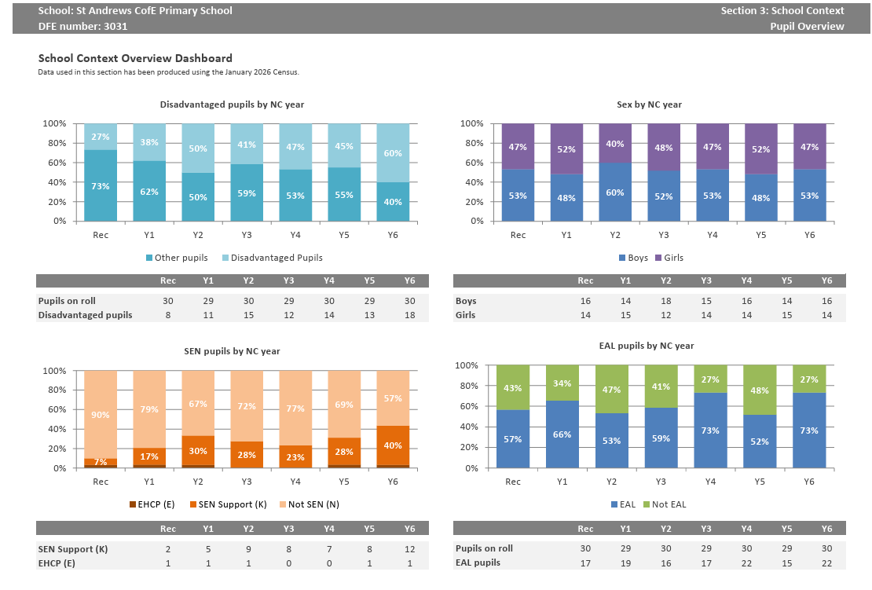  High levels of EAL  EEF finds ​“significantly lower achievement”, with a ​“large and concerning gap” for disadvantaged pupils Jan 2021  Assessments, observations, and discussions with pupils indicate underdeveloped oral language skills and vocabulary gaps among many disadvantaged pupils. These are evident from Reception through to KS2 and in general, are more prevalent among our disadvantaged pupils than their peers. Assessments, observations, and discussions with pupils suggest disadvantaged pupils generally have greater difficulties with phonics than their peers. This negatively impacts their development as readers.
2 | 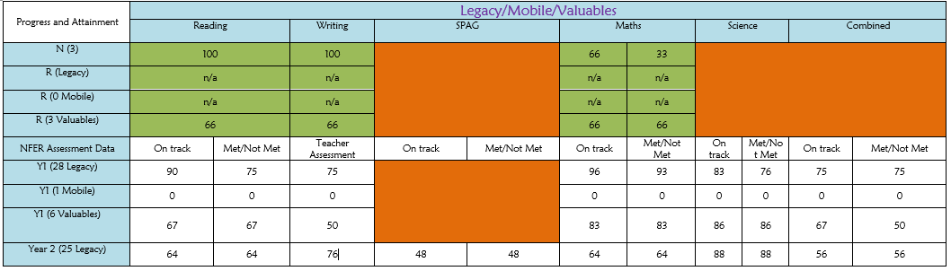  Socio-economic Disadvantage and Poverty  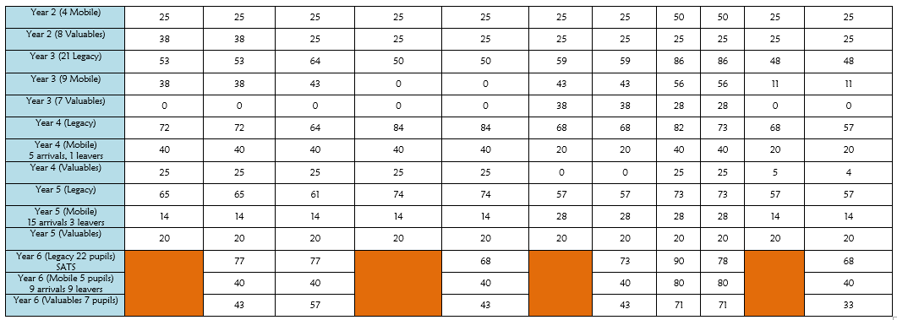  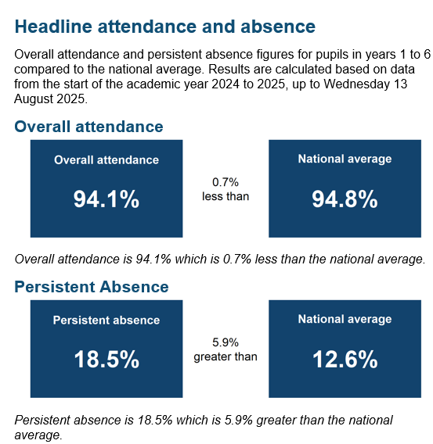  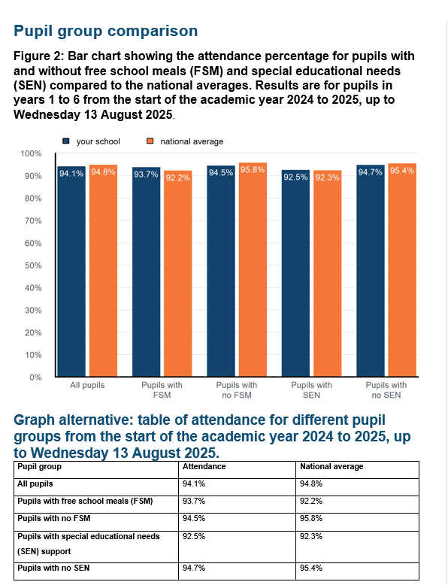  Despite our ‘School of Sanctuary’ status, school readiness – either at the start of the year in EYFS or mid year arrivals from other schools or abroad - independence, self-care, social skills, communication and language, resilience.  On entry to Reception class in the last 2 years, between 60-68% of our disadvantaged pupils arrive below age-related expectations compared to other pupils.  Our attendance data over recent years indicates that attendance among disadvantaged pupils has been lower than for non-disadvantaged pupils. Our assessments and observations indicate that absenteeism is negatively impacting disadvantaged pupils’ progress.  Despite receiving LPPA, there are low (but improving) levels of parental engagement with some of our disadvantaged pupils
3 | Speech Language and Communication Needs  St Andrew's faces a substantial speech, language and communication challenge due to the combination of a high proportion of pupils identified with SLCN (39% of the SEN cohort), exceptionally high levels of EAL (62%), significant disadvantage (43% FSM6), and below-average reading outcomes. These factors create barriers to language acquisition, vocabulary development, comprehension, social interaction and curriculum access, making communication-focused teaching and targeted intervention a key priority across the school  Speech, Language and Communication Needs – Oral Language Interventions/Preparing For Literacy EEF (2018)
4 | SEND and additional needs – has increased significantly over recent years  St Andrew's serves an increasingly complex cohort with SEND numbers having risen from 13% to 27% over the last six years. The school faces significant challenges arising from the interaction of SEND, high levels of speech, language and communication needs, a large EAL population (62%), and high disadvantage (43% FSM). Many pupils present with overlapping barriers to learning, requiring extensive adaptive teaching, targeted intervention and pastoral support. The increasing complexity of need places significant demands on staffing, specialist provision and inclusion systems while emphasising the importance of high-quality universal provision across the school.
5 | Safeguarding, Social Care and Family Vulnerability  St Andrew's serves an increasingly vulnerable community characterised by high levels of deprivation, disadvantage and complex family need. Rising numbers of pupils with SEND, significant levels of social care involvement, a highly diverse EAL population and increasing rates of persistent absence contribute to a safeguarding landscape that is becoming more complex year on year. Many children experience multiple vulnerabilities simultaneously, requiring intensive pastoral support, effective early help processes and robust multi-agency partnerships to ensure that children remain safe, visible and able to engage successfully in school life

Intended outcomes
This explains the outcomes we are aiming for by the end of our current strategy plan, and how we will measure whether they have been achieved.
Intended outcome | Success criteria
Pupils eligible for Pupil Premium, particularly those with SEND, SLCN and EAL, develop stronger oral language, vocabulary, reading fluency and comprehension skills, enabling them to access the full curriculum. | Gap between disadvantaged and non-disadvantaged pupils in reading reduces annually.  EYFS disadvantaged pupils achieve Communication and Language outcomes at least in line with other pupils.  Increased proportion of disadvantaged pupils achieve expected standard in phonics.  Reading attainment for disadvantaged pupils is at least in line with national disadvantaged outcomes.  Target pupils demonstrate improved vocabulary acquisition, comprehension and verbal reasoning through assessment and pupil progress reviews.  Increased percentage of disadvantaged pupils achieving age-related expectations in reading across all year groups.
Disadvantaged pupils with SEND make strong progress from their starting points through high-quality adaptive teaching and targeted intervention. | Internal progress measures demonstrate at least expected progress for disadvantaged SEND pupils.  Individual SEND targets are achieved for the majority of disadvantaged pupils.  Gaps between disadvantaged SEND and non-disadvantaged pupils reduce over time.  Increased proportion of disadvantaged SEND pupils achieve personalised outcomes identified through provision mapping.  Monitoring evidences consistent adaptive teaching across all classes.
Attendance for disadvantaged and vulnerable pupils improves, reducing persistent absence and ensuring pupils access learning consistently. | Disadvantaged attendance is at least in line with national disadvantaged attendance.  Persistent absence of disadvantaged pupils decreases year on year.  Persistent absence of disadvantaged SEND pupils reduces significantly.  Families identified as attendance concerns engage positively with school support plans.  Vulnerable pupils are identified and supported swiftly through attendance monitoring systems.
Disadvantaged pupils demonstrate improved emotional wellbeing, resilience and readiness to learn through effective pastoral support and strong safeguarding systems. | Pupils accessing pastoral interventions show improved wellbeing measures.  Reduction in behaviour incidents and emotional regulation concerns for identified pupils.  Vulnerable families engage successfully with Early Help and external support services.  Barriers arising from family circumstances are identified early and addressed through multi-agency working.  Vulnerable pupils report feeling safe, supported and known by trusted adults in school.  Increased family engagement in school events, workshops and support programmes.
Disadvantaged pupils experience the same breadth of curriculum, enrichment and wider opportunities as their peers. | All disadvantaged pupils participate in educational visits and enrichment activities.  Financial barriers do not prevent participation in residentials, clubs or wider experiences.  Increased participation of disadvantaged pupils in leadership roles, sport, music and extra-curricular activities.  Pupils demonstrate improved knowledge of the wider world and future aspirations through pupil voice activities.  Enhanced curriculum engagement and motivation among identified pupils.
Emerging educational, safeguarding and social vulnerabilities are identified quickly and addressed through timely intervention. | Baseline and screening assessments identify need promptly.  Targeted interventions are implemented quickly and evaluated rigorously.  Vulnerable pupils make accelerated progress following intervention.  Greater parental engagement in support plans and review processes.  SEND, safeguarding, attendance and Pupil Premium systems work cohesively to identify risk early.
Activity in this academic year
This details how we intend to spend our pupil premium (and recovery premium funding) this academic year to address the challenges listed above.

Teaching (for example, CPD, recruitment and retention)
Budgeted cost: £45543 (+ Forest School grant, Speech Bubbles funding)
Activity | Evidence that supports this approach | Challenge number(s) addressed
Purchase of standardised diagnostic assessments.  Training for staff to ensure assessments are interpreted and administered correctly. | Standardised tests can provide reliable insights into the specific strengths and weaknesses of each pupil to help ensure they receive the correct additional support through interventions or teacher instruction:  Standardised tests | Assessing and Monitoring Pupil Progress | Education Endowment Foundation | EEF | 2, 3, 4
Embedding dialogic activities across the school curriculum. These can support pupils to articulate key ideas, consolidate understanding and extend vocabulary.  We will purchase resources and fund ongoing teacher training and release time. | There is a strong evidence base that suggests oracy interventions, including dialogic activities such as high-quality classroom discussion, are inexpensive to implement with high impacts on reading:  Oral language interventions | Toolkit Strand | Education Endowment Foundation | EEF | 2, 3, 4
Embedding principles of good practice set out in the DfE’s Improving School Attendance advice.  This will involve training and release time for staff to develop and implement new procedures and appointing attendance/support officers to improve attendance. | The DfE guidance has been informed by engagement with schools that have significantly reduced levels of absence and persistent absence. | 1, 5
Contingency fund for acute issues. | Based on our experiences and those of similar schools to ours, we have identified a need to set a small amount of funding aside to respond quickly to needs that have not yet been identified. | 1, 5
Embed and enhance Read, Write, In phonics programme, focusing on applying spelling and grammar to independent writing | Validated systematic synthetic phonics programme  ‘By ensuring high-quality phonics teaching the government wants to improve literacy levels to:  give all children a solid base upon which to build as they progress through school  help children to develop the habit of reading widely and often, for both pleasure and information’  DFE July 2021  HLTAs to deliver an hour session per day | 2, 3, 4
Focus on speech, language and communication interventions – WELCOMM and Forest School | WELCOMM  The WellComm toolkits were developed by Speech and Language Therapists at Sandwell and West Birmingham Hospitals NHS Trust with the aim of providing easy to use support for everyone involved with children.  Requiring no specialist expertise, they quickly identify areas of concern in language, communication, and interaction development in order to ensure early targeted intervention.  Extend Forest School scheme to EYFS and Y1  - Confidence: children had the freedom, time and space to learn and demonstrate independence  - Social skills: children gained increased awareness of the consequences of their actions on peers through team activities such as sharing tools and participating in play  - Communication: language development was prompted by the children’s sensory experiences  - Motivation: the woodland tended to fascinate the children and they developed a keenness to participate and the ability to concentrate over longer periods of time  - Physical skills: these improvements were characterised by the development of physical stamina and gross and fine motor skills  - Knowledge and understanding: the children developed an interest in the natural surroundings and respect for the environment  Forestschool.gov.uk 2022 | 2, 3

Targeted academic support (for example, tutoring, one-to-one support structured interventions)
Budgeted cost: £93458
Activity | Evidence that supports this approach | Challenge number(s) addressed
Haven | Early identification and impact on outcomes  Flexible, individualised provision driven by careful assessment and monitoring  A strong inclusive ethos among staff  Adaptive teaching strategies that respond to the needs of specific students  Effective systems also include clear progress indicators—such as narrowing attainment gaps, maintaining access to the curriculum, improving social or self-help skills—and structured review processes involving teachers, SENCo, and leadership.  Provision and Practice for pupils with SEND Outstanding Leaders  Supporting SEND Gov.UK | 4
Use of pre and post teaching interventions, 121 sessions | EEF Guidance Report on 1-2-1 or small group interventions:  “Research… targeted interventions in one-to-one or small group settings shows a consistent impact on attainment of approximately three to four additional months’ progress (effect size 0.2–0.3).” | 2, 3, 4
Inclusion Manager/SENDCO | ‘Leading On Inclusion: The Role of the SENDCO’ 2021 Kay & Middleton  - Reduces barriers  - Increases participation and access to learning  Supports diversity | All

Wider strategies (for example, related to attendance, behaviour, wellbeing)
Budgeted cost: £8569
Activity | Evidence that supports this approach | Challenge number(s) addressed
Family Support Officer | EEF ‘ Working With Parents To Support Children’s Learning’ (2018)  DFE ‘Working Together To Improve School Attendance’ 2024  https://educationhub.blog.gov.uk/2025/08/why-school-attendance-matters-and-what-were-doing-to-improve-it/ | All
Breakfast Club | ‘to improve concentration and behaviour in class and to improve punctuality for some pupils’  Evaluation of Breakfast Clubs in Schools with High Levels of Deprivation  Research Report March 2017 DFE | 1, 5
Hardship Fund | This supports families in crisis, e.g. free uniform, Breakfast Club/School meals provision. This reflects our school ethos and the ethos of Salford Authority ‘Spirit of Salford’ | 1, 5
Cultural Capital/Educational Visits subsidy | p31 Ofsted EY Inspection Handbook  "the essential knowledge that children need to be educated citizens… Cultural capital is the essential knowledge that children need to prepare them for their future success” | 1, 5
Thrive Programme and Thrive Family Club | Thrive helps to develop resilience in young people (Hart and Heaver 2015)  Staff using the Thrive Approach feel more equipped to manage behaviour and better able to support more vulnerable children (Office for Public Management 2013)  Thrive closes the gap for vulnerable children across a range of measures including attainment, behaviour, relationships, self-confidence and attendance.  (McGuire-Snieckus et al 2015)  The Department for Education is focused on supporting schools to build whole school environments and develop approaches within which all students can achieve their full potential. A 2018 review of published policies and information - Mental health and wellbeing provision in schools - was commissioned in response to the Green Paper 'Transforming children and young people's mental health provision'. This review included Thrive as an initiative that supports and promotes positive mental health. (DfE 2018). | All
CPOMs | CPOMS is an efficient tool to enable staff to swiftly act on safeguarding and well being. This is monitored ‘in real time’ by DSLs which leads to timely actions and Thrive support for children. | 5

Total budgeted cost: £

Part B: Review of outcomes in the previous academic year

Pupil premium strategy outcomes
This details the impact that our pupil premium activity had on pupils since the inception of this strategy.
Despite serving a community characterised by high deprivation, significant SEND, high levels of EAL and increasing family vulnerability, St Andrew's has demonstrated a positive impact on disadvantaged pupils. Attendance for disadvantaged pupils remains consistently above national averages, persistent absence remains below national levels and attainment gaps have narrowed significantly over time. In 2025, disadvantaged pupils achieved outcomes above national disadvantaged averages in combined reading, writing and mathematics, writing and mathematics. Progress data also demonstrates that disadvantaged pupils have previously made stronger progress than their national peers, particularly in reading and writing. These outcomes indicate that Pupil Premium funding has been used effectively to reduce barriers to learning, improve attendance, strengthen literacy and support vulnerable pupils to achieve success despite significant contextual challenges.
Data from IDSR and Wigan pack illustrates:

1. Disadvantaged pupils perform broadly in line with or above national disadvantaged pupils
Given that:
- 43% of pupils are disadvantaged,
- 62% are EAL,
- 27% are SEND,
- deprivation is well above average,
The outcomes for disadvantaged pupils compare favourably with national disadvantaged outcomes in many areas.
KS2 Combined Reading, Writing and Maths
In 2025:
- 64% of disadvantaged pupils achieved RWM expected standard.
- National disadvantaged average was 47%.
This placed disadvantaged pupils 17 percentage points above national disadvantaged pupils.
Writing
In 2025:
- 73% of disadvantaged pupils achieved expected standard in writing.
- National disadvantaged average was 59%.
This demonstrates a significant positive impact on writing achievement.

2. The disadvantage gap has narrowed significantly
One of the strongest indicators of impact is the reduction in the gap between disadvantaged pupils and national non-disadvantaged pupils.
Combined Reading, Writing and Maths
Gap reduced from:
- -33 percentage points in 2022 to
- -6 percentage points in 2025.
Writing
Gap reduced from:
- -33 percentage points in 2022 to
- -6 percentage points in 2025.
Mathematics
Gap reduced from:
- -35 percentage points in 2022 to
- -17 percentage points in 2025.
This suggests that strategies funded through Pupil Premium have successfully reduced barriers to learning for vulnerable pupils.

3. Strong Progress for Disadvantaged Pupils
Although attainment remains a challenge because of cohort complexity, progress measures show evidence of effective school support. The IDSR indicates that disadvantaged pupils:
Reading Progress (2023)
- School disadvantaged progress score: +3.3
- National disadvantaged average: -0.9
- Recorded as a positive gap.
Writing Progress (2023)
- School disadvantaged progress score: +3.6
- National disadvantaged average: -0.7
- Again showing a positive gap.
Maths Progress (2023)
- School disadvantaged progress score: +1.6
- National disadvantaged average: -1.0.
This demonstrates that disadvantaged pupils often made stronger progress than similar pupils nationally when secure systems and interventions were in place.

4. Strong Attendance for Disadvantaged Pupils
Despite serving a highly disadvantaged community, attendance for disadvantaged pupils has consistently been above national figures.
FSM Attendance
2024/25:
- School disadvantaged attendance: 93.9%
- National disadvantaged attendance: 92.3%
This suggests that attendance systems, family engagement and pastoral support have been particularly effective with disadvantaged families.

5. Positive Impact in Early Intervention
The school's phonics outcomes show evidence that disadvantaged pupils are benefiting from early support.
Year 1 Phonics
2026 disadvantaged pupils:
- 88% achieved the expected standard.
- Local authority average: 68%.
- National average: 68%.
This suggests early literacy intervention and phonics provision are having a strong impact on disadvantaged children.

6. Effective Support for Low Prior Attainers
Many disadvantaged pupils are also low prior attainers.
The IDSR shows:
Low Prior Attainers
Reading, writing and maths combined:
- 33% achieved expected standard in 2023.
- National average for similar pupils: 12%.
This was identified as significantly above national averages.
This indicates successful targeting of intervention and support towards pupils entering Key Stage 2 from lower starting points.

Externally provided programmes
Please include the names of any non-DfE programmes that you purchased in the previous academic year. This will help the Department for Education identify which ones are popular in England
Programme | Provider
Speech, Language and Communication | WELCOMM,
Phonics | Read, Write, Inc
Accelerated Reader, MyOn | Renaissance
Reading, Writing, Spelling | Ready Steady Read, Ready Steady Write
Maths | White Rose Maths, Mathletics, Mastery In Maths
Foundation Subjects | Kapow
Online Safety | National College
EYFS | Tapestry
Times Tables | TT Rockstars
French | Primary Language Network
Music | Charanga

Further information (optional)


