Year One Homework: 11th September

Each week there will be homework to complete. This homework is spellings and a Maths task which links to our learning. If you would like to do more learning at home then please continue to read for 10mins a day, or take a look into one of our subject areas which interest you. Look at our newsletter for more ideas.
Reading in school this week.
This week we have read:
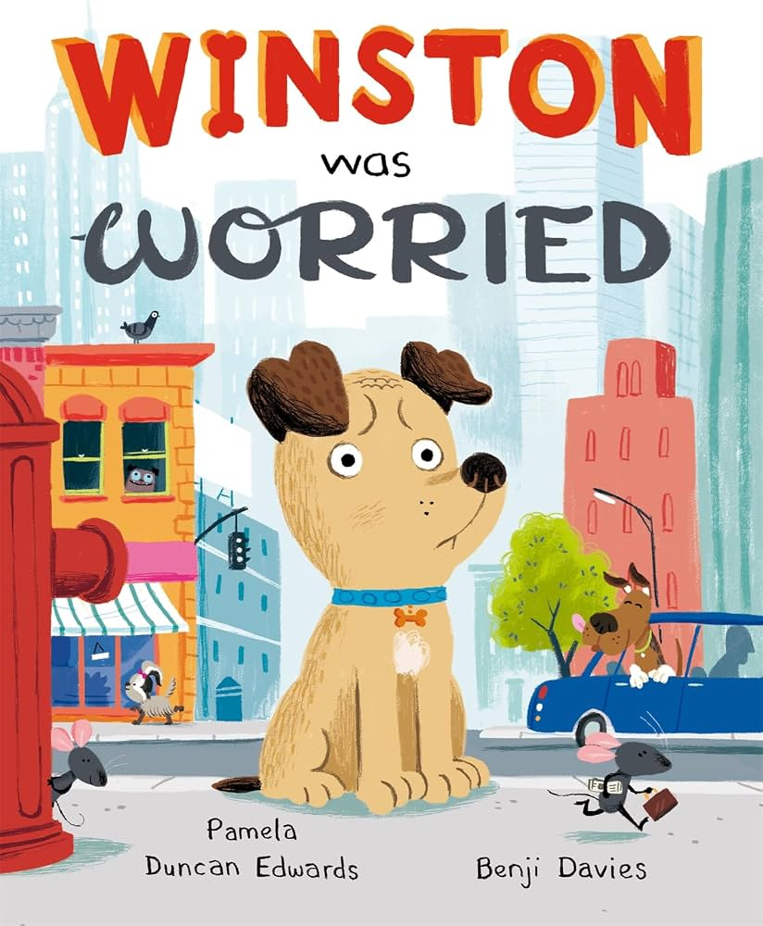

Spellings to practise at home: This week are a Reception review.

jump
test
net
wind
me

Maths homework: This can normally be found on Mathletics on this link https://login.mathletics.com/ This will be in your child’s reading record file next week once we have set the children up. In the meantime, our focus this week has been counting and recognising numbers to 10. So if you can help your child count forward and backwards and write their numbers correctly, this would be very helpful.
Thank you,
Mrs Durham

