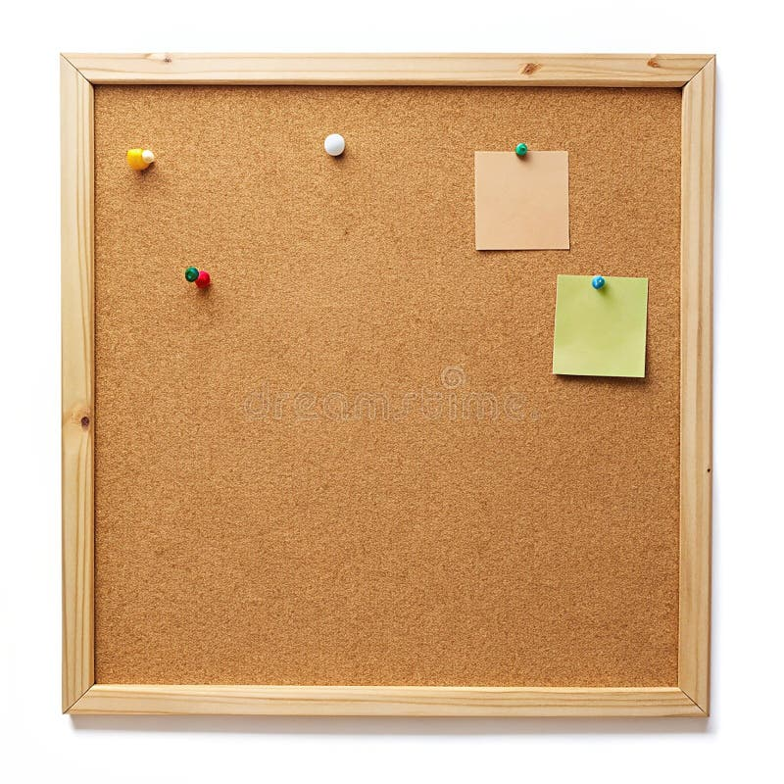

HOMEWORK TASKS AUT 2 Week 1

ONGOING TASKS
Spellings – WEEK 9
Mathletics – Log in and complete the tasks set for you. These will help build
your confidence with the maths we’re learning in class. – The login for
Mathletics is at the back of your child’s reading record.
Reading Books –Please try to read a little each day and enjoy the stories together at home! – Our reading. Don’t forget to complete your quiz on accelerated reader!
Times Tables Rock Stars – Have a go at learning the 4 times table!
Accelerated Reader –Your login details are written at the back of your
yellow reading record.



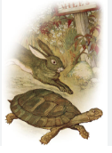
TOPIC TASK
English: We have been looking at fables in our English lesson this week, short fictional stories that convey a moral lesson or message. Can you research and have a read of some fables online? Choose your favourite one and either have it ready to tell your class in your head or you can write it down.

