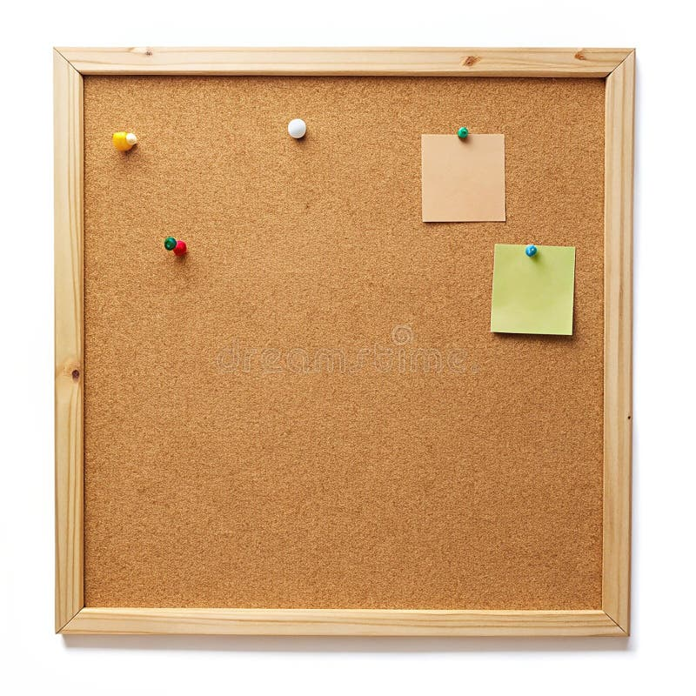

HOMEWORK TASKS AUT 2 Week 2

ONGOING TASKS
Spellings – WEEK 9
Mathletics – Log in and complete the tasks set for you. These will help build
your confidence with the maths we’re learning in class. – The login for
Mathletics is at the back of your child’s reading record.
Reading Books –Please try to read a little each day and enjoy the stories together at home! – Our reading. Don’t forget to complete your quiz on accelerated reader!
Times Tables Rock Stars – Recap 3 and 4
Accelerated Reader –Your login details are written at the back of your
yellow reading record.




TOPIC TASK
R.E: We are learning about different types of religion in R.E and how different people celebrate different special times. Do you have a special time that you celebrate? Eg. Birthdays, Christmas, Eid, etc. Can you write about it and tell your class about it?

