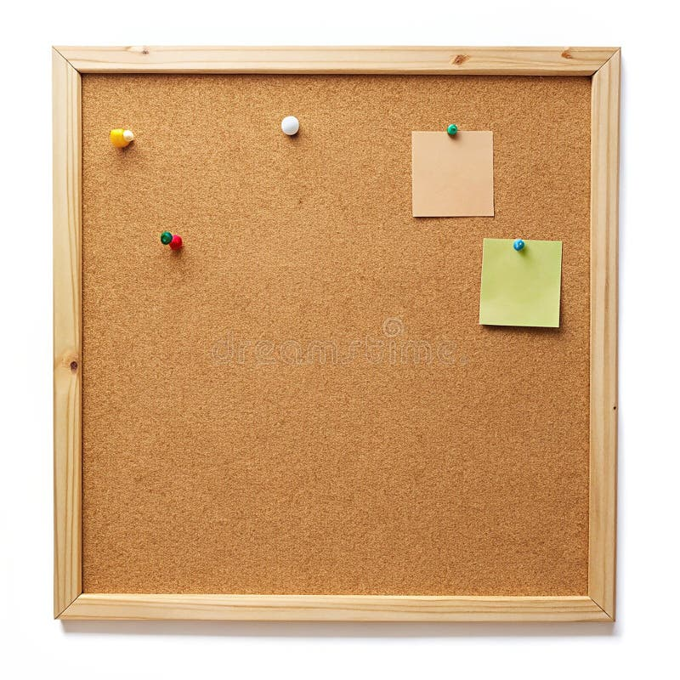

HOMEWORK TASKS AUT 2 Week 3

ONGOING TASKS
Spellings – WEEK 9
Mathletics – Log in and complete the tasks set for you. These will help build
your confidence with the maths we’re learning in class. – The login for
Mathletics is at the back of your child’s reading record.
Reading Books –Please try to read a little each day and enjoy the stories together at home! – Our reading. Don’t forget to complete your quiz on accelerated reader!
Times Tables Rock Stars – Recap 3 and 4
Accelerated Reader –Your login details are written at the back of your
yellow reading record.




TOPIC TASK
French: The children are learning numbers 1-10 in French. Can you have a practice at home using the youtube link: https://www.youtube.com/watch?v=76qsPzD1PTk
You don’t need to write anything down this week

