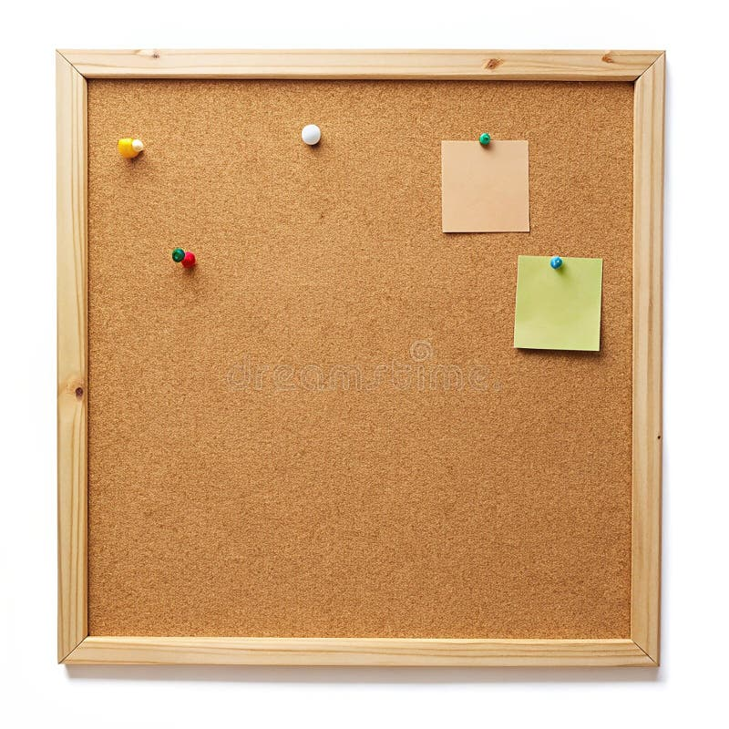

HOMEWORK TASKS Spring 2 Week 1

ONGOING TASKS
Spellings – WEEK 18
Mathletics – Log in and complete the tasks set for you. These will help build
your confidence with the maths we’re learning in class. – The login for
Mathletics is at the back of your child’s reading record.
Reading Books –Please try to read a little each day and enjoy the stories together at home! – Our reading. Don’t forget to complete your quiz on accelerated reader!
Times Tables Rock Stars – 4 times-table
Accelerated Reader –Your login details are written at the back of your
yellow reading record.

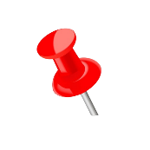

TOPIC TASK
In Art this half term, we are exploring Ancient Egypt.

Look closely at the image and write down what you can see in the piece of artwork, what colours the artist has used and what you think some of the symbols mean.
