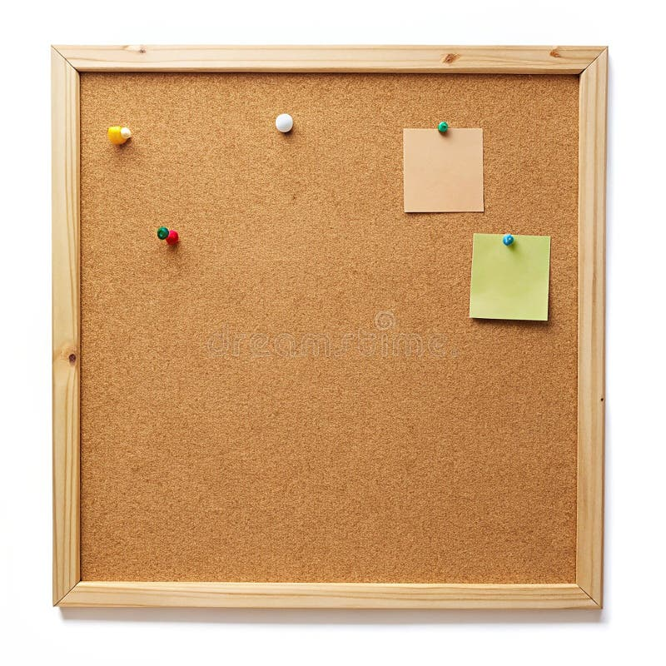

HOMEWORK TASKS Spring 2 Week 2

ONGOING TASKS
Spellings – WEEK 19
Mathletics – Log in and complete the tasks set for you. These will help build
your confidence with the maths we’re learning in class. – The login for
Mathletics is at the back of your child’s reading record.
Reading Books –Please try to read a little each day and enjoy the stories together at home! – Our reading. Don’t forget to complete your quiz on accelerated reader!
Times Tables Rock Stars – 4 and 8 times-tables
Accelerated Reader –Your login details are written at the back of your
yellow reading record.



TOPIC TASK
Find a range of different objects at home (5 or 6 objects if you can). Test each object with a fridge magnet to test if it is magnetic or not magnetic.

Choose how you want to present your results e.g. create a table with your results.



