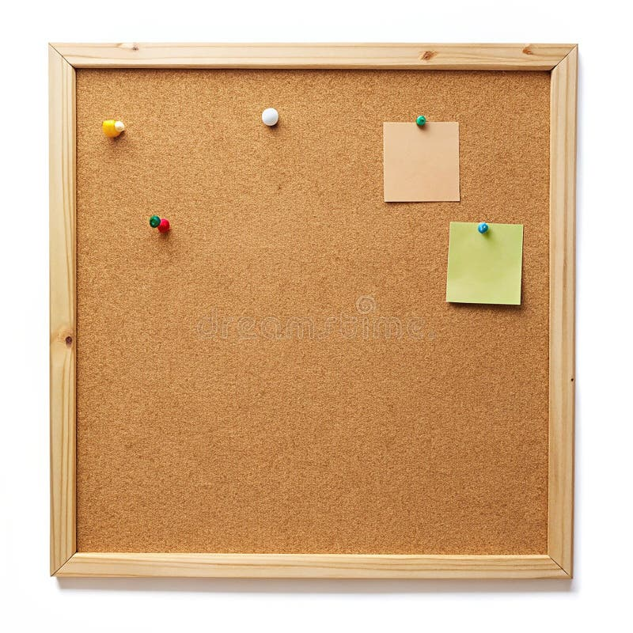

HOMEWORK TASKS Spring 2 Week 3

ONGOING TASKS
Spellings – WEEK 20
Mathletics – Log in and complete the tasks set for you. These will help build
your confidence with the maths we’re learning in class. – The login for
Mathletics is at the back of your child’s reading record.
Reading Books –Please try to read a little each day and enjoy the stories together at home! – Our reading. Don’t forget to complete your quiz on accelerated reader!
Times Tables Rock Stars – 3 times table
Accelerated Reader –Your login details are written at the back of your
yellow reading record.

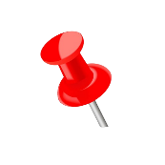

TOPIC TASK
An artefact is an object made by a person that historians can use to learn about the past.

Write down what you think each artefact might have been used for and what questions you would ask about each artefact.

