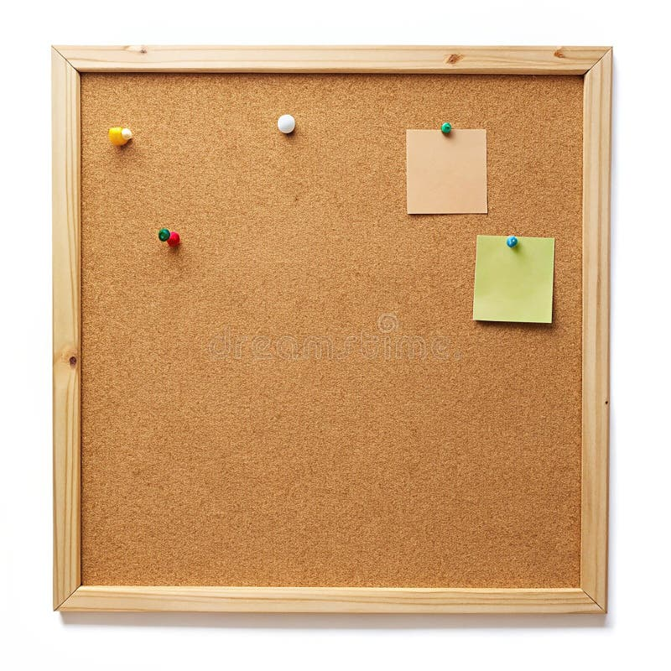

HOMEWORK TASKS Spring 2 Week 4

ONGOING TASKS
Spellings – WEEK 20 (no new spellings for this week)
Mathletics – Log in and complete the tasks set for you. These will help build
your confidence with the maths we’re learning in class. – The login for
Mathletics is at the back of your child’s reading record.
Reading Books –Please try to read a little each day and enjoy the stories together at home! – Our reading. Don’t forget to complete your quiz on accelerated reader!
Times Tables Rock Stars – 8 and 3 times-tables
Accelerated Reader –Your login details are written at the back of your
yellow reading record.

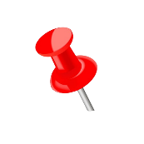
TOPIC TASK
This week we have been learning about light in Science, looking at the difference between light sources and non-light sources.

Find 5 or 6 light sources (or as many as you can find) at home and write down whether it is a natural or artificial source of light.

Challenge – Why is it a source of light?

