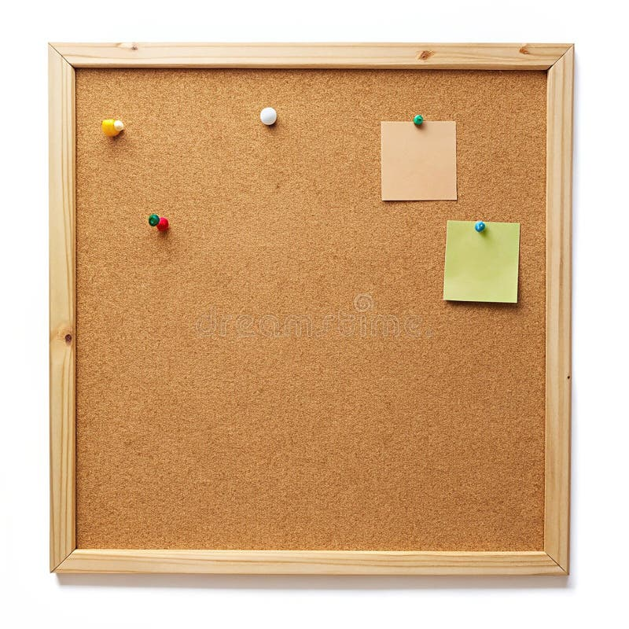

HOMEWORK TASKS Spring 2 Week 6

ONGOING TASKS
Spellings – WEEK 21
Mathletics – Log in and complete the tasks set for you. These will help build
your confidence with the maths we’re learning in class. – The login for
Mathletics is at the back of your child’s reading record.
Reading Books –Please try to read a little each day and enjoy the stories together at home! – Our reading. Don’t forget to complete your quiz on accelerated reader!
Times Tables Rock Stars – 3, 4 and 8 times-tables
Accelerated Reader –Your login details are written at the back of your
yellow reading record.


TOPIC TASK
Boudicca Betrayed comprehension to be completed – This should be in your bags

In RE we have been learning about Believer’s Baptism and Infant Baptism.
Write down the similarities and differences between them.

