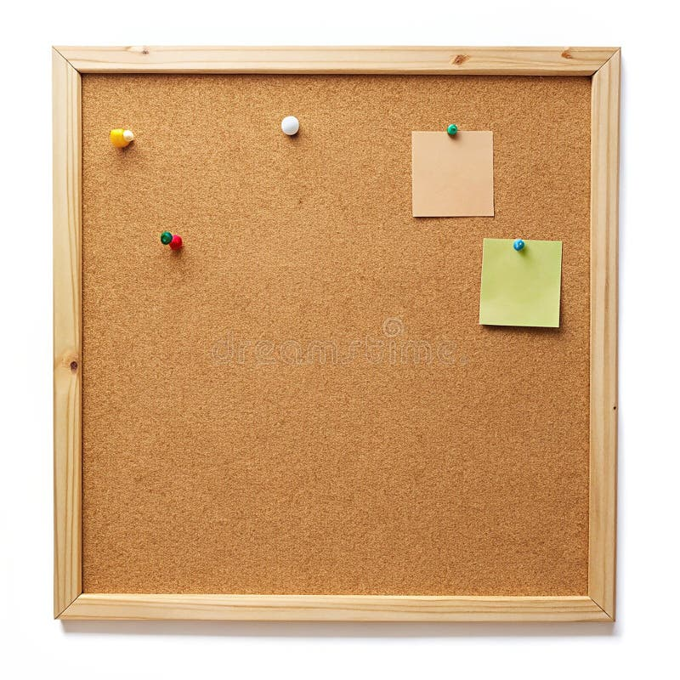

HOMEWORK TASKS Summer 1 Week 1

ONGOING TASKS
Spellings – WEEK 22
Mathletics – Log in and complete the tasks set for you. These will help build
your confidence with the maths we’re learning in class. – The login for
Mathletics is at the back of your child’s reading record.
Reading Books –Please try to read a little each day and enjoy the stories together at home! – Our reading. Don’t forget to complete your quiz on accelerated reader!
Times Tables Rock Stars – 6 times tables
Accelerated Reader –Your login details are written at the back of your
yellow reading record.



TOPIC TASK
In Science this week we have been investigating how shadows are formed.

Pick three items in your home. Using a torch (this can be a torch or a torch on a phone) shine it on the objects and draw the shadows of each object.

