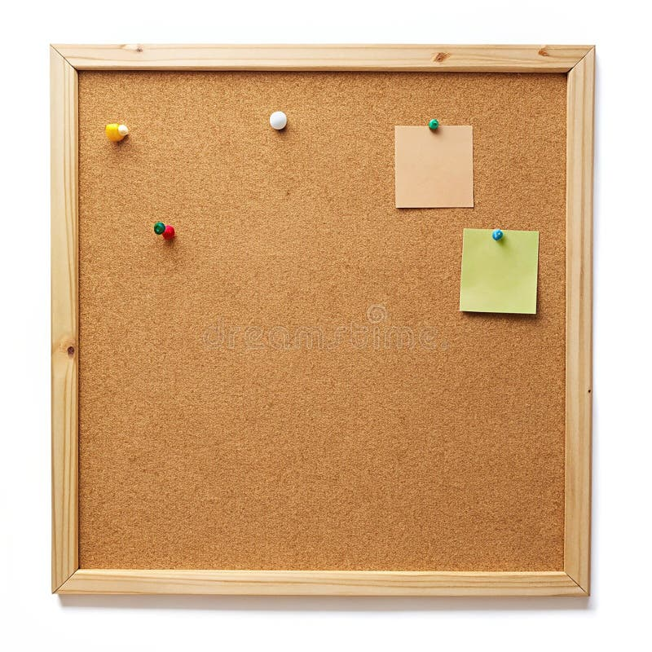

HOMEWORK TASKS Summer 1 Week 2

ONGOING TASKS
Spellings – WEEK 23
Mathletics – Log in and complete the tasks set for you. These will help build
your confidence with the maths we’re learning in class. – The login for
Mathletics is at the back of your child’s reading record.
Reading Books –Please try to read a little each day and enjoy the stories together at home! – Our reading. Don’t forget to complete your quiz on accelerated reader!
Times Tables Rock Stars – 6 and 8 times-tables
Accelerated Reader –Your login details are written at the back of your
yellow reading record.


TOPIC TASK
In History this week we have been looking at Gods and Goddesses in Ancient Egypt.
Research a God or Goddess of your choice. Make a colourful fact file about them. This should include:

- Name of the God or Goddess
- What they were the God or Goddess of
- Why they were important
- A drawing
- One interesting fact

