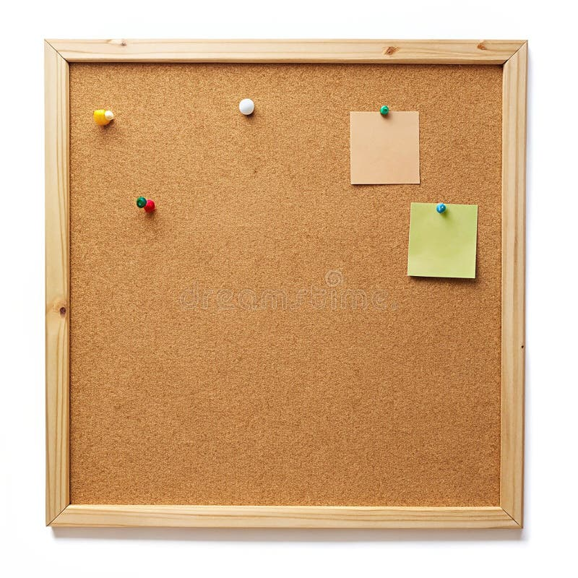

HOMEWORK TASKS AUT 2 Week 4

ONGOING TASKS
Spellings – WEEK 9
Mathletics – Log in and complete the tasks set for you. These will help build
your confidence with the maths we’re learning in class. – The login for
Mathletics is at the back of your child’s reading record.
Reading Books –Please try to read a little each day and enjoy the stories together at home! – Our reading. Don’t forget to complete your quiz on accelerated reader!
Times Tables Rock Stars – 8 times-table
Accelerated Reader –Your login details are written at the back of your
yellow reading record.




TOPIC TASK
Click the below link to explore the information about Earthquakes. We will be learning more about this next week. Can you tell me some facts about Earthquakes before our lesson?
https://www.bbc.co.uk/bitesize/topics/zd68h4j/articles/z7gkwnb#zyyckty

