Homework Week 1
Mathletics
As we are about to move onto a new topic in Maths that we haven’t looked at yet, I have set three new topics on Addition and Multiplication as a recap.
Times Table Rock Stars
We have now learnt all of our times-tables in class. As our compulsory times-tables test is edging nearer, the children need to now work on their speed at answering times-tables calculations in a random order quickly. To achieve this, I would like you to continue accessing Times Table Rock Stars (https://ttrockstars.com/ ).
As well as this, there is a Maths game called Hit the Button, which we often play in class. Here the children can work on answering times-tables calculations while being timed. I would like the children to work on mixed calculations. (https://www.topmarks.co.uk/maths-games/hit-the-button ).
On Fridays, we will continue to have times-tables quizzes, but these will now be mixed questions.
Please access and practise your times-tables daily, even if it is just five minutes per day! It is extremely important that we know them all for our test!
Foundation
Please practise our poem ‘Gran, can you rap?’ ready for performing on World Book day (5th March 2025)
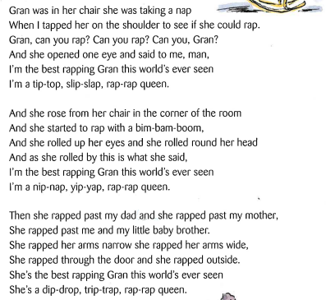
Spellings
Please practise these spellings for your spelling test on Friday 6th March 2026.
Group 1 | Group 2
height | crab
minute | ship
notice | slit
favourite | chop
opposite | grin
often | snip
disappear | fret
special | snag
eight | shot
circle | blot

